Evolution of SARS-CoV-2 During Cross-Species Transmission

The evolution of SARS-CoV-2 during cross-species transmission is depicted in the figure below.

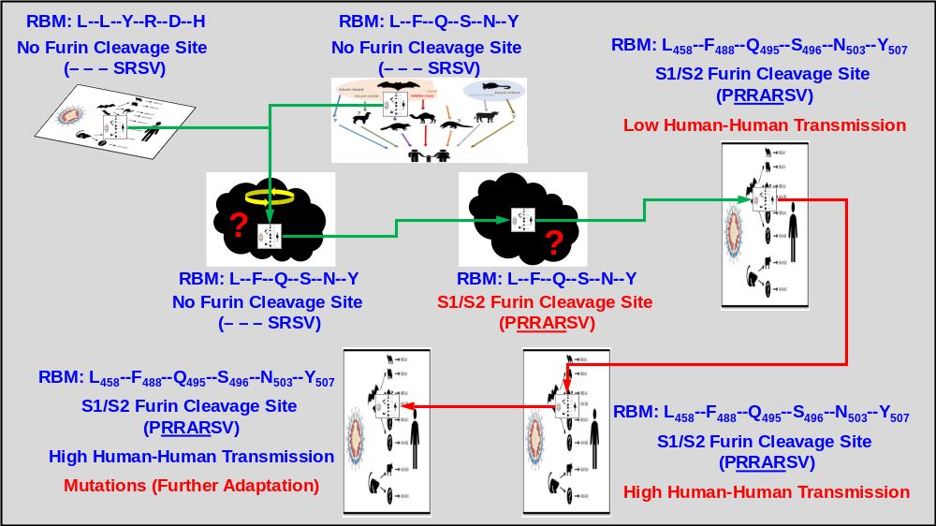

Reservoir and Intermediate Hosts of SARS-CoV-2
- Reservoir host is an animal harboring a SARS-related coronavirus that has a high sequence identity with SARS-CoV-2.
- Bat is probably the reservoir host for SARS-CoV-2. This is because a coronavirus RaTG13 isolated from bat (Rhinolophus affinis) shows a sequence identity of 96.2% to the SARS-CoV-2 at the genome level, which is the highest among those that were reported thus far.
- However, the receptor binding motif (RBM) in the SARS-CoV-2 Spike protein is significantly different from that of RaTG13. In fact, the receptor binding domain (RBD) and RBM of SARS-CoV-2 is very similar to that of a coronavirus isolated from a dead Malayan pangolin (Pangolin-CoV).
- Although the genome sequence identity of Pangolin-CoV to SARS-CoV-2 (91.0%) is lower than that of RaTG13 to SARS-CoV-2 (96.2%), some Pangolin-CoV genes show higher amino acid sequence identity to SARS-CoV-2 genes than to RaTG13 genes. These include:
- Orf1b (73.4% vs.72.8%),
- Spike (S) protein (97.5% vs.95.4%),
- Orf7a (96.9% vs.93.6%), and
- Orf10 (97.3% vs. 94.6%).
- These observations thus suggest that the ancestor of SARS-CoV-2 may be the product of a recombination event of RaTG13 and Pangolin-CoV in an animal species that has yet to be identified, which functions as an intermediate host during the zoonotic transfer of SARS-CoV-2 into humans.
- Since the virus in this animal has the same RBM as SARS-CoV-2, this intermediate host should have an ACE2 protein that is structurally similar to the human counterpart.

Therefore, it is of interest to investigate if (and in what extent) the human and pangolin ACE2 proteins are structurally similar.
- If they are structurally similar, identification of the animal species with ACE2 that is structurally similar to the human and pangolin proteins will provide some clues about the identity of this intermediate host.
- If they are structurally different, identification of the animal species with ACE2 that can bind SARS-CoV-2 Spike protein better that the pangolin counterpart will provide some insight into the identity of this intermediate host.

These species, domestic animals or wild animals, should have an opportunity to come into close contact with humans.
- Initially, multiple sequence alignment of ACE2 may be performed to narrow down potential candidates.
- This will be followed by homology modeling (i.e. 3-D protein structure and docking analysis) of SARS-CoV-2 Spike and the respective ACE2 from the potential candidates to identify the putative intermediate host(s) for SARS-CoV-2.

The technical approach to investigate the intermediate hosts of SARS-CoV-2 during its development and zoonotic transmission is depicted in the figure below.

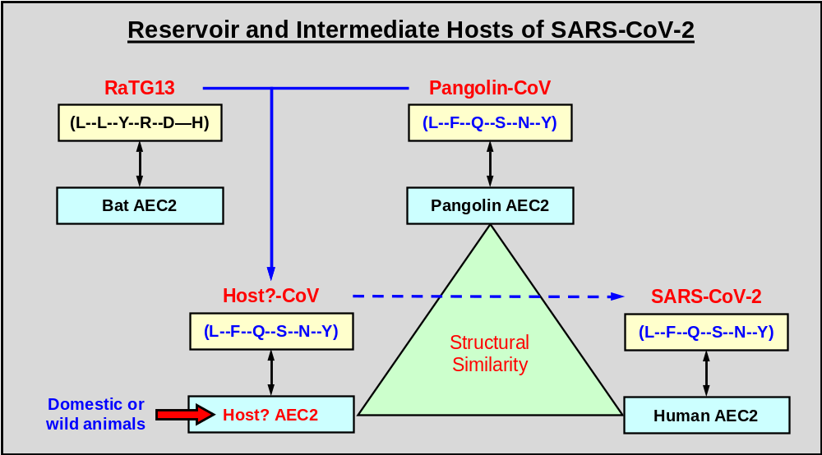
Evolution of SARS-CoV-2
- Ancestors / Parents of SARS-CoV-2
- It is widely believed that SARS-CoV-2 is gradually evolved from a bat SARS-related coronavirus (Bat-SARSr-CoV), and the sequence identity of these viruses to SARS-CoV-2 should gradually increase during this process. These viruses should have a higher sequence identity than that of RaTG13 to SARS-CoV-2.
- One of the event in this process is the acquisition of a furin cleavage site in the S1/S2 junction, which is not present in the RaTG13 and Pangolin-CoV genomes.

Once the putative intermediate host(s) are identified (above), it will be of interest to investigate if they harbor any coronaviruses that show high sequence identity to SARS-CoV-2, RaTG13 and Pangolin-CoV.
- The analysis should not be limited to the whole genome. Any coronaviral fragments (genomic or mRNA) in the public databases should be extracted and analyzed.
- Initially, phylogenetic analysis, at the genome level, may be performed to investigate if there is any coronavirus with a sequence identity to SARS-CoV-2 higher than that of RaTG13.
- In addition to the whole genome, phylogenetic analysis at the gene level should also be performed. The SARS-CoV-2 genomes encodes for many proteins (including nsp1-16, Spike (S), Envelope (E), Membrane (M) and Nucleocapsid (N), and at least six accessory proteins. Therefore, phylogenetic analysis of each of these genes/proteins in SARS-CoV-2 genome should also be analyzed. Regions of interest include the RBD/RBM, the polybasic cleavage site at the S1–S2 junction, the S2’ cleavage site, and the O-linked glycans that flank the polybasic cleavage sites in the Spike protein.
- If there are viral sequences that show higher sequence identity to SARS-CoV-2 than that of RaTG13, they are likely the ancestors of SARS-CoV-2, or they at least provide some genetic materials for the SARS-CoV-2 genome. The animals that harbor these viruses likely function as the intermediate hosts of SARS-CoV-2
- To identify recombination events during the evolution of SARS-CoV-2, similarity plot analysis of viral genomes will also be performed.

- Further Evolution and Adaptation of SARS-CoV-2 in Humans
SARS-CoV-2 likely further evolves to better adapt in humans, and more than 55,000 viral genomic sequences have been determined so far. This provides an opportunity to investigate the changes in several important properties, such as transmission, morbidity and mortality, of SARS-CoV-2.
- Extract all available SARS-CoV-2 genome sequences from the GISAID and NCBI Databases.
- Build a directional phylogenetic network to identify paths of transmission through different countries and regions based on the date of diagnosis of the disease.
- Use other metadata to tag the nodes (including disease severity, outcome, etc.)
- Based on this network, estimate the transmission routes of COVID-19 during this global pandemic.

- In-depth analysis of mutations in each gene (changes in nucleotide and amino acid sequences)
- Predict structural and functional changes in the viral proteins that have harbored mutations and perform 3-D protein structure and docking analysis if needed.
- Based on these results, estimate potential changes in the transmission, morbidity and mortality of SARS-CoV-2.

The technical approach of studying the evolution of SARS-CoV-2 during its development and zoonotic transmission is depicted in the figure below.

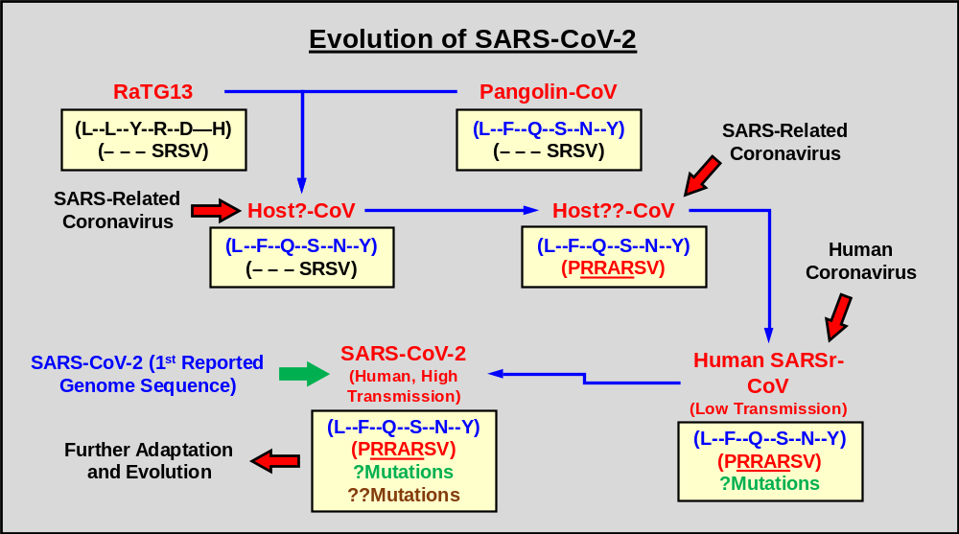

Resources
- NCBI Virus (https://www.ncbi.nlm.nih.gov/labs/virus/vssi/#/)
- NCBI Viral Genome Database (https://www.ncbi.nlm.nih.gov/genome/viruses/)
- Virus Pathogen Resource (ViPR, https://www.viprbrc.org/brc/home.spg?decorator=vipr)
- Virus-Host Database (https://www.genome.jp/virushostdb/)
- GISAID Database (GISAID EpiFlu database)
- Genomes Pages - Virus (https://www.ebi.ac.uk/genomes/virus.html)
- NCBI BioProject Database
- NCBI NR Protein Database
- UniProt Database
- NCBI GenBank Database
- NCBI Sequence Read Archive (SRA) Database
- Genomic tRNA Database (GtRNAdb, ttp://gtrnadb.ucsc.edu/)
- Genomes Pages - At the EBI (https://www.ebi.ac.uk/genomes/)

